Agile Sprint Planning & User Story Workshop
Smart Electric Vehicle Charging Network Management Platform
Course: Software Engineering (CSA10 / CSA1063)
Assessment: CO1 Assessment Tool 2 — Agile Sprint Planning & User Story Workshop
CO Assessed: CO1 — Apply advanced methodologies and agile project management techniques

TABLE OF CONTENTS
S.NO | TOPIC | PAGE NO.
1 | PROJECT VISION AND STAKEHOLDERS | 3
2 | EPICS AND USER STORIES | 4-5
3 | ACCEPTANCE CRITERIA | 6-7
4 | PRODUCT BACKLOG PRIORITIZATION | 8-9
5 | SPRINT BACKLOG PLANNING | 10-11
6 | STORY POINT ESTIMATION | 12
7 | SPRINT GOAL AND EXPECTED DELIVERABLES | 13

1. Project Vision and Stakeholders

1.1 Project Vision
To build a unified, intelligent, and scalable Smart Electric Vehicle Charging Network Management Platform that connects EV owners, charging station operators, and network administrators on a single digital system — enabling real-time station discovery, advance slot reservation, automated payments, and data-driven network management, in order to remove the uncertainty and inefficiency of today's fragmented EV charging experience and support wider EV adoption.

1.2 Project Objectives
- Give EV owners real-time visibility of station availability and the ability to reserve a slot in advance.
- Automate the charging session lifecycle from authentication to payment.
- Provide station operators with real-time monitoring and proactive fault alerts.
- Provide administrators with analytics for data-driven network planning and load management.
- Deliver the platform iteratively using Agile Scrum so that high-value features reach users early and often.

1.3 Key Stakeholders
Stakeholder | Role / Interest in the Project
EV Owner / Driver | Primary end user — searches, reserves, charges, and pays through the mobile app.
Charging Station Operator | Owns/operates physical stations; needs monitoring, fault alerts, and revenue visibility.
Network Administrator | Manages platform-wide configuration, users, pricing, and analytics.
Product Owner | Owns and prioritizes the product backlog on behalf of the business.
Scrum Master | Facilitates the Scrum process and removes team impediments.
Development Team | Designs, builds, and tests the mobile app, backend services, and IoT integration.
Payment Gateway Provider | External stakeholder providing secure transaction processing.
Field Maintenance Technician | Acts on fault alerts raised by the platform to repair stations.

2. Epics and User Stories
The product backlog is organized into five Epics, each representing a major capability of the platform. Each Epic is broken down into User Stories written in the standard Agile format: "As a <user>, I want <feature>, so that <benefit>."

Epic 1: Station Discovery and Booking
- US1 — As an EV owner, I want to search for nearby charging stations on a map, so that I can quickly find a station close to my current location.
- US2 — As an EV owner, I want to view the real-time availability of charging slots at a station, so that I don't waste time travelling to an occupied station.
- US3 — As an EV owner, I want to reserve a charging slot in advance, so that I can guarantee a slot will be available when I arrive.

Epic 2: Charging Session Management
- US4 — As an EV owner, I want to authenticate myself at the charging station using a QR code or RFID card, so that the session starts securely under my account.
- US5 — As an EV owner, I want to start and stop my charging session from the mobile app, so that I have full control over the charging process.

Epic 3: Payment and Billing
- US6 — As an EV owner, I want the platform to automatically calculate the cost of my charging session, so that I don't have to manually work out the charges.
- US7 — As an EV owner, I want to pay for my charging session digitally through the app, so that I have a fast, cashless, and secure checkout experience.

Epic 4: Station Monitoring and Maintenance
- US8 — As a station operator, I want to receive a real-time alert when a charger malfunctions, so that I can arrange a repair quickly and minimize downtime.
- US9 — As a station operator, I want to view the live status of all my charging stations on a dashboard, so that I can manage day-to-day operations efficiently.

Epic 5: Admin Analytics and Reporting
- US10 — As a network administrator, I want to view usage and revenue analytics across the entire network, so that I can make informed decisions about where to expand the network.
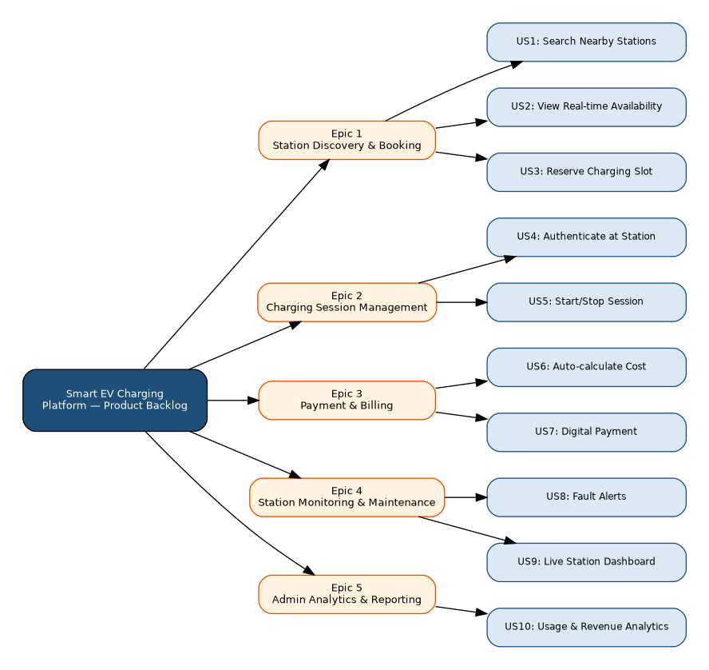
Figure 2.1: Epic-to-User-Story Breakdown

3. Acceptance Criteria
Acceptance criteria for each user story are written in the Given–When–Then format to ensure they are specific, testable, and measurable.

US1: Search Nearby Stations
- Given the EV owner has location permission enabled, When they open the station search screen, Then the app displays all charging stations within a 10 km radius on a map.
- Given no stations exist within the default radius, When the search completes, Then the app prompts the user to expand the search radius.

US2: View Real-time Availability
- Given a station is displayed on the map, When the EV owner taps the station, Then the current number of available and occupied connectors is shown, updated within the last 30 seconds.
- Given a station goes offline, When its status changes, Then the app reflects the updated status within 1 minute.

US3: Reserve Charging Slot
- Given an available slot at a station, When the EV owner selects a time and confirms, Then the slot is reserved and held for 15 minutes pending arrival.
- Given a reservation is not honoured within the hold window, When the timer expires, Then the slot is automatically released back to the pool.

US4: Authenticate at Station
- Given an EV owner has an active reservation, When they scan the station's QR code or tap their RFID card, Then the system verifies their identity and unlocks the connector within 5 seconds.
- Given an invalid or expired QR/RFID credential, When authentication is attempted, Then the system denies access and displays an error message.

US5: Start/Stop Charging Session
- Given a successfully authenticated session, When the EV owner taps 'Start Charging' in the app, Then the charging station begins delivering power and the app shows a live session timer.
- Given an active session, When the EV owner taps 'Stop Charging', Then the station halts power delivery within 5 seconds and the session is marked complete.

US6: Auto-calculate Cost
- Given a completed charging session, When the session ends, Then the system calculates the cost based on energy consumed (kWh) and the applicable tariff, accurate to two decimal places.

US7: Digital Payment
- Given a calculated charging cost, When the EV owner confirms payment, Then the amount is charged via the integrated payment gateway and a digital invoice is generated within 10 seconds.
- Given a payment failure, When the transaction is declined, Then the app notifies the user and allows a retry with an alternate payment method.

US8: Fault Alerts
- Given a charging station reports an abnormal sensor reading, When the anomaly is confirmed, Then an alert is sent to the responsible operator within 2 minutes, including the fault type and station ID.

US9: Live Station Dashboard
- Given a station operator logs into the web dashboard, When the dashboard loads, Then it displays the live status (available / occupied / faulty) of every station they manage.

US10: Usage and Revenue Analytics
- Given sufficient historical session data exists, When an administrator opens the analytics dashboard, Then usage trends, peak demand periods, and revenue by station are displayed for a selectable date range.

4. Product Backlog Prioritization
The product backlog is prioritized using the MoSCoW technique (Must have, Should have, Could have) combined with a Value-vs-Effort assessment, ensuring that high-value, foundational stories are delivered first.
Rank | User Story | Business Value | Effort (Story Points) | MoSCoW Priority
1 | US1 — Search Nearby Stations | High | 5 | Must Have
2 | US2 — Real-time Availability | High | 5 | Must Have
3 | US4 — Authenticate at Station | High | 5 | Must Have
4 | US3 — Reserve Charging Slot | High | 8 | Must Have
5 | US7 — Digital Payment | High | 5 | Must Have
6 | US6 — Auto-calculate Cost | Medium | 3 | Should Have
7 | US5 — Start/Stop Session | Medium | 3 | Should Have
8 | US9 — Live Station Dashboard | Medium | 5 | Should Have
9 | US8 — Fault Alerts | High | 8 | Should Have
10 | US10 — Usage & Revenue Analytics | Medium | 8 | Could Have

Stories US1, US2, US4, US3, and US7 form the foundation of the platform's core value proposition — discovering, booking, authenticating, and paying for a charging session — and are therefore ranked as 'Must Have' for the first release. US5 and US6 support that core flow and are 'Should Have'. Operator- and admin-facing stories (US8, US9, US10) depend on session data being generated first, so while valuable, they are prioritized after the owner-facing flow is functional.
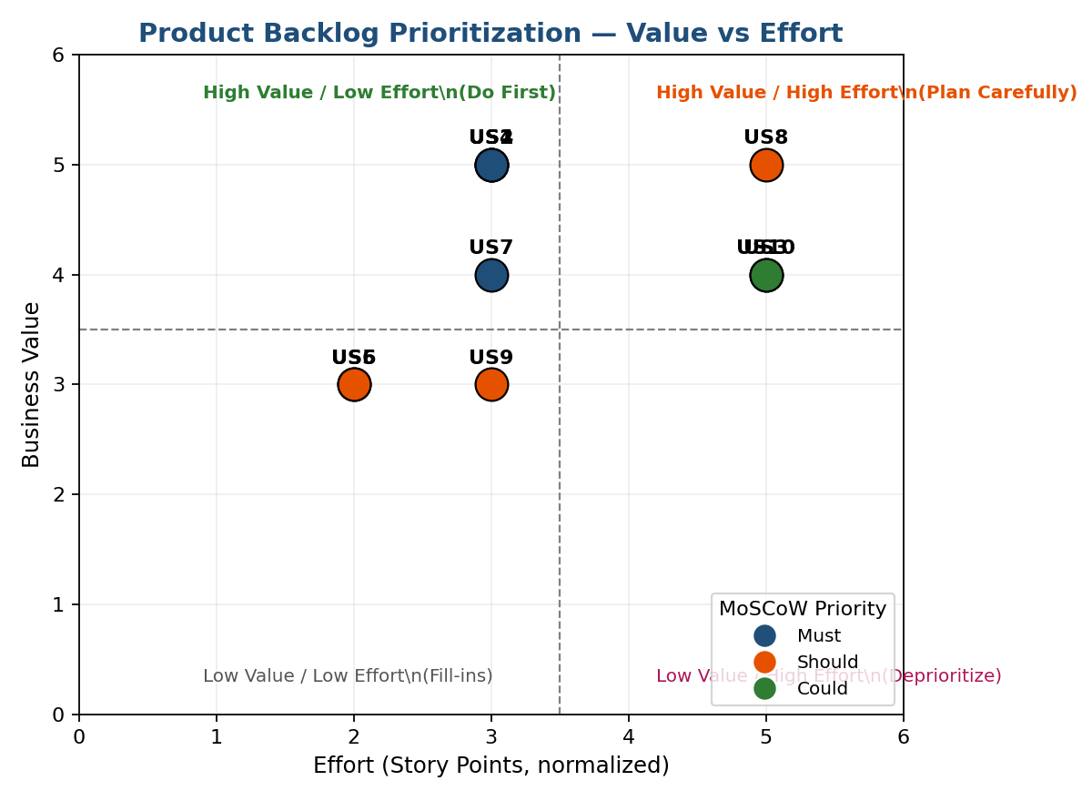
Figure 4.1: Product Backlog Prioritization — Value vs Effort Matrix

5. Sprint Backlog Planning
Based on the prioritized backlog, the four highest-priority, foundational user stories are selected for Sprint 1. These stories together deliver a complete, demonstrable slice of value: an EV owner can find a station, see its live availability, reserve a slot, and authenticate on arrival.

5.1 Sprint 1 Backlog — Selected User Stories
User Story | Story Points | Development Tasks
US1 — Search Nearby Stations | 5 | Design map UI; integrate mapping SDK; build station-search API; implement radius filter; write unit tests.
US2 — Real-time Availability | 5 | Design IoT-to-cloud status pipeline; build availability API; implement 30-second polling/push update in app; write integration tests.
US3 — Reserve Charging Slot | 8 | Design reservation data model; build booking API with hold-timer logic; implement reservation UI; implement auto-release job; write tests.
US4 — Authenticate at Station | 5 | Design QR/RFID authentication protocol; build authentication API; implement scanner integration on station controller; implement error handling; write tests.

5.2 Sprint 1 Board
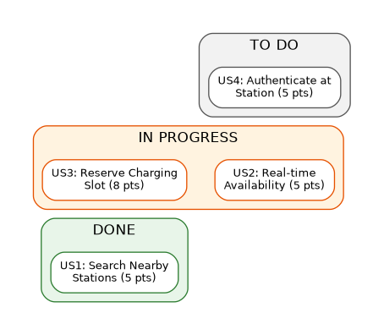
Figure 5.1: Sprint 1 Kanban Board (Illustrative Mid-Sprint Snapshot)

5.3 Sprint Capacity
Total Sprint 1 backlog: 23 story points. Based on the development team's estimated velocity of approximately 23–25 points per two-week sprint, this backlog is considered a realistic and achievable commitment for Sprint 1.

6. Story Point Estimation
Story points are estimated using the Fibonacci sequence (1, 2, 3, 5, 8, 13...) via Planning Poker, where the development team independently estimates each story's relative complexity, effort, and uncertainty before converging on a consensus value.
User Story | Story Points | Justification
US1 — Search Nearby Stations | 5 | Requires map SDK integration and a geospatial search API; moderate complexity, low uncertainty.
US2 — Real-time Availability | 5 | Requires a live IoT data pipeline and near-real-time UI updates; moderate complexity.
US3 — Reserve Charging Slot | 8 | Involves state management (hold timers, auto-release), concurrency handling, and UI; higher complexity and risk.
US4 — Authenticate at Station | 5 | Requires secure QR/RFID protocol design and hardware-software integration; moderate complexity.
US5 — Start/Stop Session | 3 | Simple command-and-acknowledge flow once authentication exists; low complexity.
US6 — Auto-calculate Cost | 3 | Straightforward calculation logic based on metered energy and tariff; low complexity.
US7 — Digital Payment | 5 | Requires secure third-party payment gateway integration and error/retry handling; moderate complexity.
US8 — Fault Alerts | 8 | Requires anomaly detection logic on sensor data and a reliable notification pipeline; higher complexity.
US9 — Live Station Dashboard | 5 | Requires a real-time multi-station dashboard UI; moderate complexity.
US10 — Usage & Revenue Analytics | 8 | Requires data aggregation across the network and a reporting/visualization layer; higher complexity.

Total product backlog: 55 story points across 10 user stories. Sprint 1 commits 23 points, representing the highest-priority, foundational slice of the backlog.

7. Sprint Goal and Expected Deliverables

7.1 Sprint Goal
"Enable an EV owner to search for a nearby charging station, view its real-time slot availability, reserve a slot in advance, and authenticate successfully at the station to begin a charging session."

7.2 Expected Sprint 1 Deliverables
- A functional station-search screen with map view and radius filtering (US1).
- A live availability indicator for each station, updated in near real-time from IoT sensor data (US2).
- A working slot-reservation flow with a 15-minute hold timer and automatic release (US3).
- A QR-code/RFID authentication flow that securely unlocks the charging connector for a reserved user (US4).
- Automated unit and integration tests covering all four Sprint 1 stories.
- A Sprint Review demo showing the end-to-end flow: search → view availability → reserve → authenticate.

7.3 Sprint Burndown Plan
The Sprint 1 burndown chart below shows the planned (ideal) versus projected actual completion of the 23 committed story points across the two-week sprint, based on the team's task breakdown and estimated daily capacity.
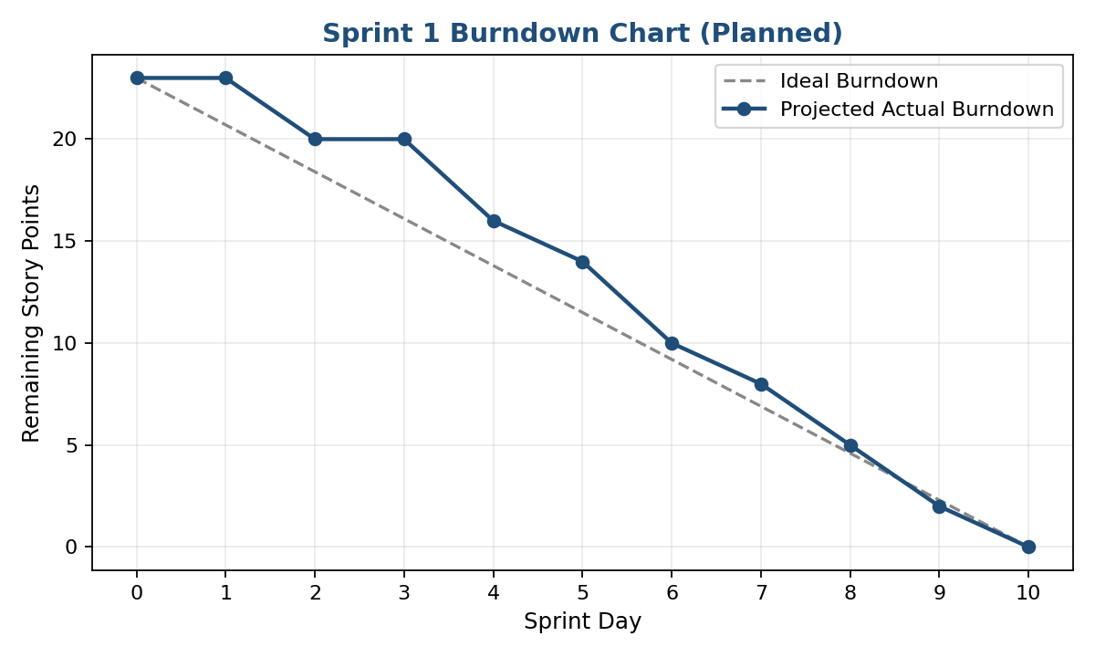
Figure 7.1: Sprint 1 Burndown Chart (Planned)
This Agile Sprint Planning and User Story Workshop demonstrates a structured, iterative approach to delivering the Smart EV Charging Network Management Platform — starting with a clear vision and stakeholder map, decomposing the system into well-formed epics and user stories, defining measurable acceptance criteria, prioritizing the backlog by business value, and committing to a realistic, achievable Sprint 1 that delivers a demonstrable increment of customer value.

